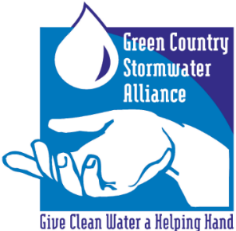
GCSA Workbook
Prepared by INCOG
June 2020, v1

GCSA EMPLOYEE TRAINING ON STORMWATER 101
Part 2: Phase II Permittees and OKR04 Permit Overview
Prepared by INCOG, June 2020
The following information contains PowerPoint slides with associated discussion of each topic. This is the 2nd of 5 Workbooks covering INCOG’s updated Stormwater 101 Education and Outreach for its GCSA Members. The material will benefit not only new staff who may be unfamiliar with stormwater permit requirements, but will also help city management and elected officials understand this complicated permit program.
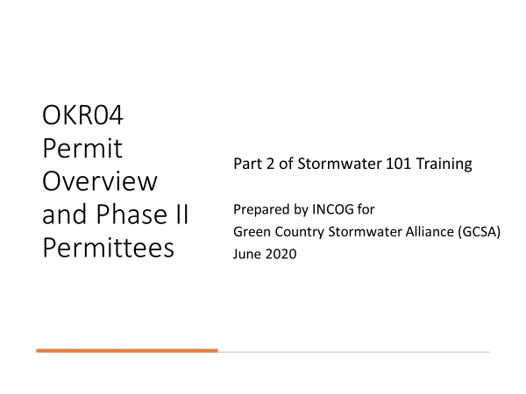
SLIDE 1: Welcome to the 2nd of 5 Workbooks addressing the basics of stormwater permitting in Oklahoma, including city and county requirements under your permit.
Part 2 will cover the identification of Phase II stormwater permittees in Oklahoma and provide an overview of the OKR04 stormwater General Permit for Small MS4 discharges.
Definitions and acronyms are keys to understanding these stormwater permit programs. There are so many different types of pollutant sources in urban stormwater that EPA developed multiple subcategories of the most important ones and split them between 3 separate types of stormwater permits.
In addition, the EPA rules covering stormwater permitting were rolled out 9 years apart into what is now called Phase I and Phase II stormwater.
INCOG’s Green Country Stormwater Alliance (GCSA) provides technical support and resources for one of these categories, the Phase II municipal stormwater dischargers.
These include cities and counties that have been designated as permitted dischargers under EPA’s Phase II rules. The Oklahoma Department of Environmental, Quality (DEQ) is the stormwater Permitting Authority (PA) for the Phase II program.
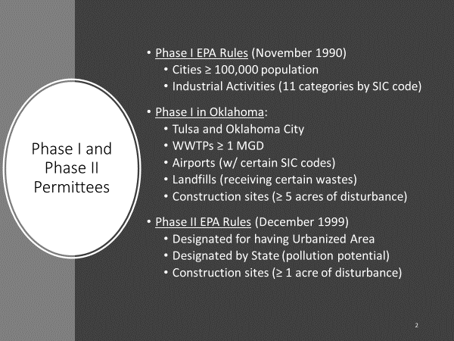
SLIDE 2: EPA’s Phase I rules for controlling urban storm water pollution were finalized in November 1990.
EPA divided its coverage over 2 main pollution source categories: large cities and numerous industrial activities under 11 subcategories.
The Phase I rules only applied to two cities in Oklahoma (Tulsa and Oklahoma City). But the industrial activities under Phase I applied to many Oklahoma cities.
As one of the 11 industrial categories, any city having a wastewater treatment plant (WWTP) with a design capacity greater than or equal to (≥) 1 million gallons per day (MGD) required a Phase I stormwater permit.
Another industrial category affecting cities was airports having certain SIC codes. A third industrial activity affecting cities was landfills that received certain types of wastes.
One of the 11 categories of Phase I industrial activities was construction sites that disturbed 5 acres or more. This became such an important Phase I industrial activity that EPA broke it out into its own separate permit track.
After several years of struggle, EPA decided upon a permitting strategy for both the large municipalities and all the 11 industrial activities.
Municipalities over 100,000 population would apply for “Individual Stormwater Permits”. EPA also produced two separate “General Permits” for the 11 categories of industrial activities: a “Construction General Permit” (CGP) and a “Multi-Sector General Permit” (MSGP) for all of the other 10 industrial activities.
In 1997, EPA granted stormwater permitting authority (PA) to the Oklahoma DEQ. DEQ began preparing Oklahoma versions of EPA’s General Permits which became OKR10 for construction activities and OKR05 for the other 10 industrial activities.
In December 1999, EPA finalized Phase II stormwater rules. Phase II addressed stormwater pollution from designated cities under 100,000 population. Designation was based upon either having US Bureau of Census “Urbanized Area” (UA) or if the state PA determined any non-UA city might have the potential to contribute significant pollution.
EPA’s Phase II rules also reduced the size of soil disturbance at construction sites from 5 acres to 1 acre. This change, which resulted from EPA losing a lawsuit, brought in a great number of additional construction sites under stormwater permits.
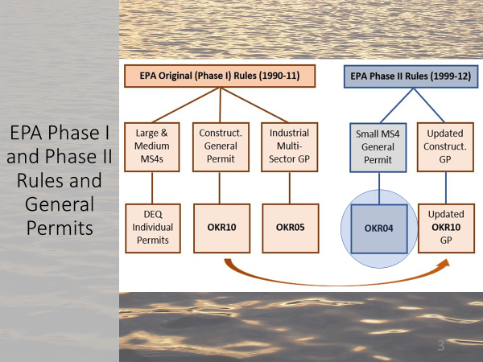
SLIDE 3: This graphic shows the relationship between Phase I and Phase II rules and the resulting EPA and state General Permits that came from the rules.
EPA’s Phase I rules resulted in Individual Permits for “Large and Medium” cities (“MS4s” which will be defined shortly), as well as two EPA General Permits, one for construction and the other for the remaining industrial activities.
Oklahoma’s DEQ adopted the EPA’s rules and created their state versions of these permits. In Oklahoma, construction General Permits (GPs) fall under DEQ’s OKR10 permit, while the other industrial activities fall under DEQ’s OKR05 permit.
Likewise, EPA’s Phase II rules triggered a new GP in Oklahoma for those smaller cities and counties newly designated as needing stormwater permits. These Phase II municipalities (cities and counties) can either be covered under an individual permit or covered under DEQ’s OKR04 General Permit for “small MS4s”.
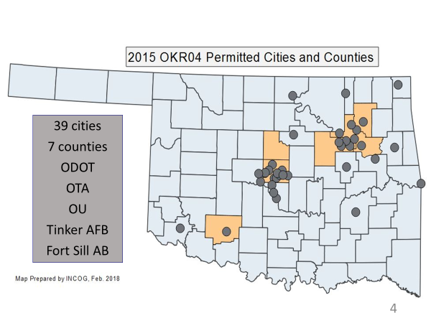
SLIDE 4: Oklahoma presently has 39 cities under the OKR04 permit, along with 7 counties and 5 non-municipal entities.
The map shows that most of these Phase II permittees are clustered around Oklahoma’s major metropolitan Urbanized Areas.
There are 10 additional cities that were found by DEQ to be significant contributors of stormwater pollution that required Phase II permit coverage. All Phase II permittees in Oklahoma except ODOT have coverage under OKR04. ODOT has an individual permit.
DEQ is proposing to add two new Phase II permittees, both in western Oklahoma, in the 2020 OKR04 renewal. All of the other permittees shown on the map are “existing permittees” (called “renewal permittees” in OKR04), and as such are expected to now have fully functioning stormwater management programs.
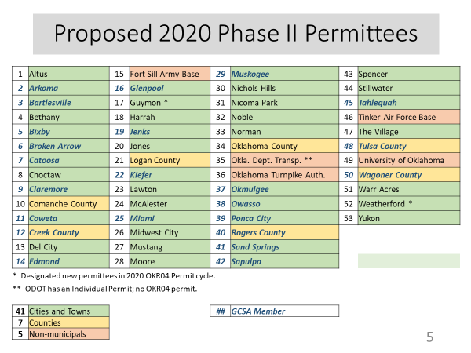
SLIDE 5: This table lists all Phase II permittees in Oklahoma including the two proposed new permittees to be added in 2020: Guymon and Weatherford.
INCOG’s present 23 GCSA MS4s represent about half of Oklahoma’s Phase II MS4 permittees.
DEQ’s draft 2020 OKR04 permit Fact Sheet lists 10 cities and 2 counties that are potential Phase II permittees but are proposed for waivers by DEQ for this permit cycle.
If the draft 2020 OKR04 permit is approved with DEQ’s 53 proposed Phase II permittees, Oklahoma will have 41 cities, 7 counties and 5 non-municipals. The updated Phase II lineup will likely have 52 OKR04 permittees and 1 individual permittee, ODOT.
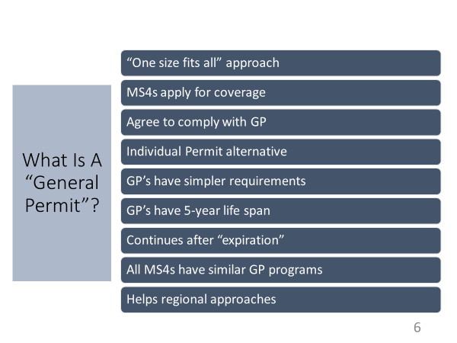
SLIDE 6: An individual permit requires negotiations between the permittee and the Permitting Authority. The resulting permit typically has more difficult compliance requirements, so GPs are preferred.
A GP begins at the top; the PA assembles all of the compliance requirements they want all permittees to address.
Because permittees are so diverse in population, MS4 size, resources and staff potential, GPs are written with generalized language, such as “Implement and enforce a program to…”.
Rather than stating exactly what should be in the local plan, a GP allows each permittee to develop and implement a local strategy that best suits their local conditions and available resources.
Coverage is a simple matter of submitting an application form to DEQ. However, at the time of submittal, the MS4 must have their detailed compliance strategy fully developed. This is called a “Stormwater Management Program (SWMP); it is a lengthy document of procedures, schedules and activities that the permittee agrees to implement under the OKR04 permit.
Permittees can modify their SWMPs as needed to reflect changing local conditions. OKR04 provides instructions for making SWMP changes.
One benefit of working under a GP is that all permitted MS4s in Oklahoma have similar requirements and are thus able to network together. This encourages the sharing of resources, data, information, and helps regional approaches, such as GCSA, for common technical support.
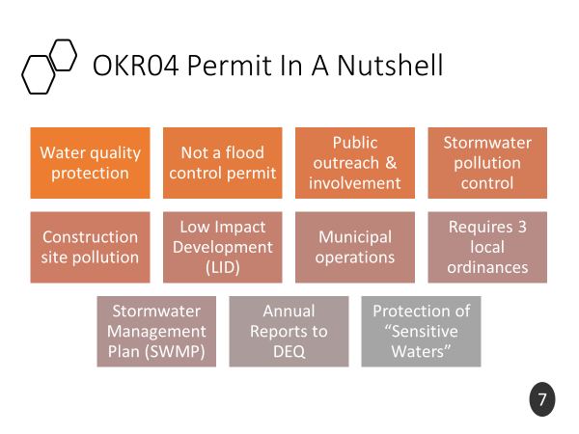
SLIDE 7: The OKR04 GP has a number of elements that reflect EPA and DEQ rules and requirements to control pollution in urban storm water runoff.
First and foremost, OKR04 is a water quality permit, not a flood control permit. While there are some crossover aspects of flood control, OKR04’s only purpose is to reduce pollution in storm water from urban runoff.
There are 6 “Minimum Control Measures” (MCMs) that form the core of the Phase II permit program. These are presented later, but in general they address public education and involvement, stormwater pollution control and enforcement, construction site pollution control, strategies to control pollution after construction has ended, and controlling pollution at the permittee’s own facilities.
OKR04 also requires that the permittee adopt three local ordinances regarding these 6 MCMs. Permittees are also required to develop and maintain a detailed SWMP document that specifies all of their activities they will implement for full compliance with the OKR04 permit.
The SWMP must list all of the Best Management Practices (BMPs) that the permittee intends to implement to meet permit requirements. Most activities under OKR04 are defined as BMPs.
OKR04 also requires that each permittee report annually to DEQ on all activities they performed over the preceding year. The report must include an assessment of how successful their program was in reducing stormwater pollution.
Being a water quality permit, OKR04 has special provisions to protect sensitive waters which are discussed at the end of this Workbook. These include waterbodies that have been designated by DEQ as 303(d) impaired, those that have had a special TMDL water quality study, those with protected species and their critical habitat, and those designated as outstanding resources.
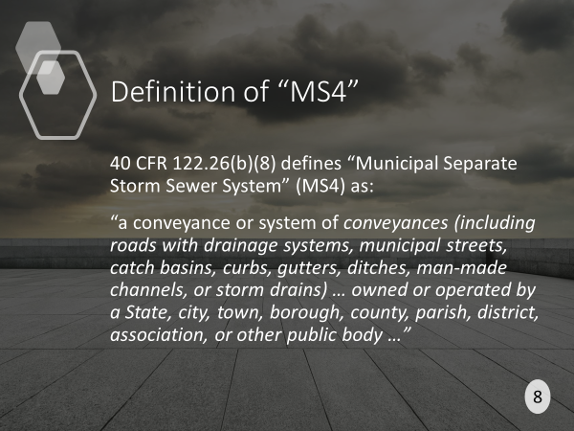
SLIDE 8: There are several definitions that are important to the stormwater permit program.
The most important of these is “MS4” (Municipal Separate Storm Sewer System).
“MS4” refers not only to the actual collection system of storm water in an urban area, but also to the city or county permittee itself as “the MS4”.
Examples of these are: “stormwater flowing to the MS4 must be treated.”, and “the permitted MS4 must implement BMPs”.
The definition of MS4 is copied verbatim from EPA regulations. Notice that the examples of MS4 cited in the definition include roads, drainage systems, streets, curbs, gutters, ditches and man-made channels.
This means that most all systems in urban areas that convey stormwater are defined as MS4.
Another important concept is ownership of the MS4: “owned or operated by a … city, … county…”. In other words, “municipally owned”. This means that private roads and ditches are not part of a city’s MS4.
Many permitted MS4 cities have within their MS4 area streets and highways that they do not own or operate, or other types of stormwater conveyance, such as private ditches or detention basins on private property.
Permitted MS4s under OKR04 are responsible for discharges to the MS4 that they “own or operate”. In addition, OKR04 requires that their local ordinances “or other regulatory mechanisms” must grant the MS4 authority over discharges from non-municipal areas as much as possible, such as from local businesses or residential properties. The MS4 must implement strategies to control pollutants from such non-municipal sources that discharge into the permittee’s MS4.
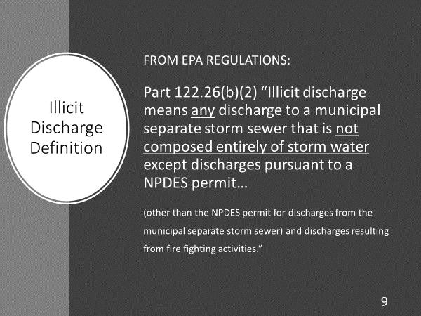
SLIDE 9: The term used in stormwater permits for a discharge of pollutants is “illicit discharge”.
Notice that the definition does not specify types or quantities of pollutants, it prohibits “any discharge … that is not composed entirely of storm water”.
This is actually a practical concept for small MS4s that have few resources and little to no training in water quality, sampling and data interpretation.
If a permitted MS4 is notified about, or discovers on its own inspection, a pollutant source that has the potential to enter its MS4 system, the MS4 can take immediate action under its local codes to stop the pollutant.
This can be done either by using the enforcement provisions in local codes to have the “Responsible Party” correct the illicit discharge, or if no Responsible Party can be identified (e.g., an illegal dump of chemicals), then the MS4 must take appropriate action to “eliminate” the pollution source.
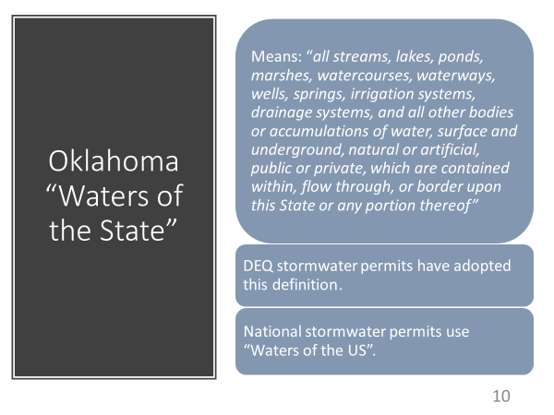
Because the definition of illicit discharge is so broad, the MS4 does not have to collect samples for analysis nor compare results to determine if a water quality standard is being violated. Any discharge of any pollutant is prohibited under OKR04.
SLIDE 10: Another important definition in stormwater permitting defines the natural waters that receive discharges from pollutant sources directly or from MS4 systems.
Oklahoma’s Stormwater General Permits use the Oklahoma definition of “Waters of the State” to refer to such “Receiving Streams”. EPA’s national Phase I and Phase II stormwater regulations refer to a federal definition, called “Waters of the US” (WOTUS).
Notice that the Waters of the State definition covers nearly all types of waterways, “…surface and underground, natural or artificial, public or private…”.
This definition means that MS4s do not have to guess whether or not a body of water is protected under OKR04; they all are, with but a few minor exceptions.
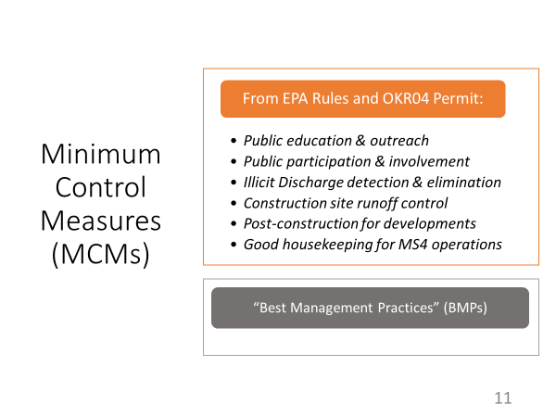
SLIDE 11: A core feature of the OKR04 permit is to address 6 Minimum Control Measures (MCMs) by implementing a variety of BMPs. The 6 MCMs in OKR04 are:
- Public Education and Outreach: using a variety of BMPs, such as brochures, local broadcast media, etc. Each MS4 can select their suite of BMPs that best suit their local conditions.
- Public Participation and Involvement: These BMPs go beyond education to active involvement and participation by local citizens, businesses and organizations. Popular BMPs for this MCM include volunteer stream monitoring, citizen help with local school in-class water quality education events, and stream cleanup events.
- Illicit Discharge Detection and Elimination (IDDE): This encompasses the search for and elimination of all reported or observed pollution events. Each MS4 must develop a program to “detect and eliminate” Illicit Discharges. A stormwater system map must be prepared, and an IDDE ordinance must be adopted that provides adequate enforcement capabilities. The MS4 must also implement a Dry Weather Field Screening (DWFS) program to search for illicit discharges.
- Construction Site Runoff Control: The MS4 must adopt a local ordinance prohibiting the discharge of sediment and other pollutants from active construction sites that disturb ≥ 1 acre of soil, whether as an individual site or as part of a “Common Plan of Development”. MS4 inspectors must inspect construction sites for inadequate sediment and pollutant controls on site and enforce local codes.
- Post-Construction Management In New Development and Redevelopment: Over the years, this has been the most difficult MCM to implement. EPA’s intent was to have local MS4s encourage, even require as warranted, the adoption of construction and development strategies that would reduce stormwater pollution from the project itself once active construction was completed. Such concepts are called Green Infrastructure and Low Impact Development (LID). OKR04 requires each MS4 to adopt an ordinance to encourage or require post-construction BMPs to reduce pollution during the life of the developed site.
- Pollution Prevention / Good Housekeeping For MS4 Operations: This MCM requires that the MS4 apply pollution inspection and control to its MS4 operations. These include MS4-owned buildings, facilities, staging areas, parks, storage areas and even maintenance of the MS4 system itself. Self-inspections and self-enforcement are to be used, along with documenting progress.
MS4’s address these 6 MCMs by implementing specific Best Management Practices (BMPs).
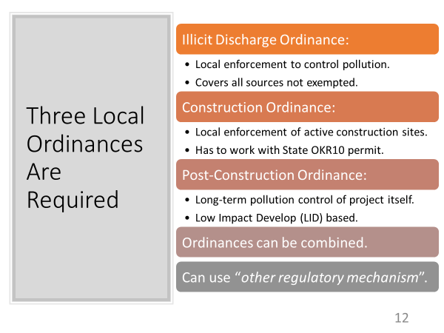
SLIDE 12: The IDDE Ordinance must provide adequate authority to stop pollution from all sources that are not exempted.
It must provide effective pollution prohibitions and have escalating enforcement provisions.
The Construction Ordinance must cover all types of pollution that can be discharged from active construction sites, such as sediment, chemicals and even paper wastes.
This ordinance must also have effective pollution prohibitions and escalating enforcement provisions. It must also be compatible with DEQ’s OKR10 permit requirements.
The Post-Construction Ordinance must address OKR04 requirements to encourage or set local requirements for controlling pollution from the project itself after construction has been completed.
Typical BMPs for this are on-site Low Impact Development (LID) pollution controls.
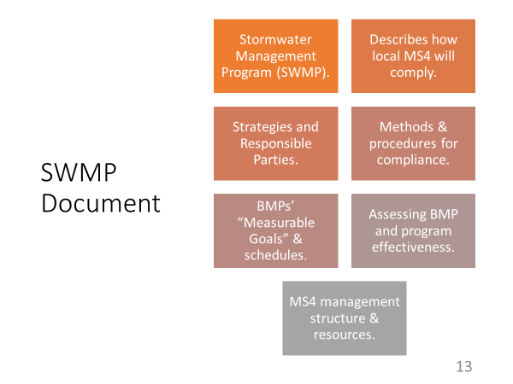
Some MS4s have combined their three required storm water ordinances into a single stormwater ordinance. Others have incorporated the OKR04 requirements into local building and development codes.
SLIDE 13: OKR04 requires that each MS4 prepare and update as needed a Stormwater Management Program (SWMP) document.
The SWMP lays out all actions that the MS4 will take to comply with all aspects of their OKR04 permit.
The SWMP includes all BMPs, and the Measurable Goal and schedule of implementation for each BMP.
The SWMP is intended to be the go-to document for all methods and procedures, including how to assess program and BMP effectiveness.
The SWMP also includes the program management structure and all management and reporting officials. The SWMP should be reviewed and updated annually.
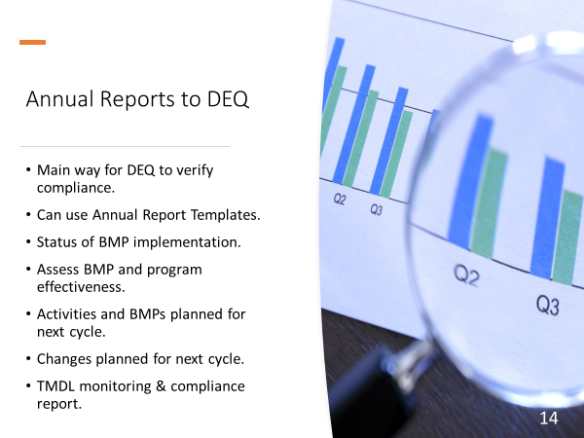
SLIDE 14: OKR04 requires each MS4 to submit an Annual Report (AR) to DEQ.
The AR is the main way that DEQ learns about how well each MS4 is complying with the permit.
The AR also describes any problems faced by the MS4 and the steps the MS4 plans to take to correct the problems.
OKR04 provides a checklist of items that must be included in the AR. The MS4 can use an Annual Report Template or prepare their AR as they wish as long as all OKR04-required items are included.
If the MS4 has to comply with a TMDL, then the TMDL requires that an annual report of all TMDL activities and monitoring results must be submitted with the MS4’s AR.
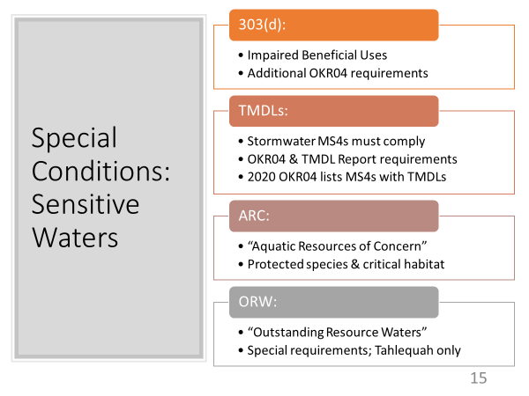
SLIDE 15: In addition to the routine requirements under the 6 MCMs, OKR04 requires that each MS4 provide special protections for sensitive waters.
These include 303(d) listed impaired waters, Completed TMDLs that have been activated by DEQ to which MS4s must comply, Aquatic Resources of Concern (ARC) for protected species, and Outstanding Resource Waters (ORW) to protect special waters defined in the WQS.
OKR04 has a Section for “Special Conditions” that defines the extra requirements for 303(d), TMDLs and ORW. Waterbodies defined as ARC are listed in an OKR04 appendix. MS4s having ARC areas within their MS4 area will have ARC requirements, but these requirements are listed in several places in the OKR04 text.
303(d) Listed and TMDL Waterbodies must have additional BMPs implemented and assessed annually. MS4s must establish priority areas for implementing BMPs and for performing inspections and monitoring to locate and control the 303(d) and/or TMDL “Pollutants of Concern” (POCs) that are the basis of the 303(d) listing and TMDL.
TMDLs, in particular, must follow a rigorous program of formal monitoring and pollution control, and separate plans for each must be adopted, along with formal Quality Assurance documents and annual reporting to DEQ of data and progress.
There is only one MS4 in Oklahoma affected by ORW requirements in OKR04, Tahlequah, due to part of their MS4 being within the watershed of an Oklahoma Scenic River. Requirements to address ORW were finalized years ago between the MS4, DEQ and other parties.
These special waters will be covered in greater detail in Part 4 of this Stormwater 101 Series.
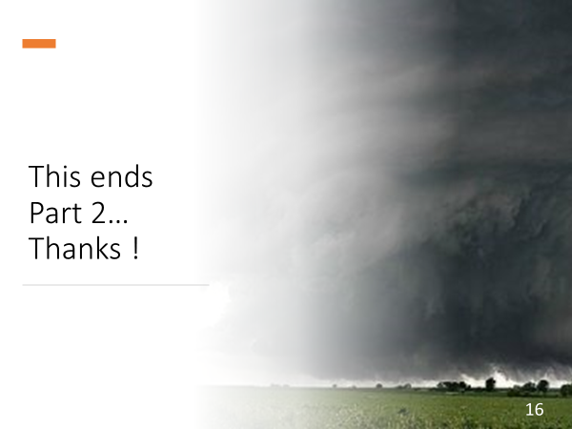
SLIDE 16: This ends Part 2 of INCOG’s Stormwater 101 Workbook series on the basics of stormwater permitting and water quality protection.
Part 3 will address the 6 MCMs in greater detail.
Part 4 will address the four categories of special sensitive waters.
Part 5 will address the latest changes being proposed by DEQ in the draft 2020 OKR04 permit.
Please contact INCOG at stormwater@incog.org or (918) 579-9451 if you have any questions about GCSA or the material in this document. Thanks !

INCOG DISCLAIMER: The information provided by INCOG does not necessarily reflect the views and positions of other persons or agencies. Please consult DEQ stormwater staff for information about stormwater permit requirements, implementation, assessments and enforcement. Also, contact INCOG for information about INCOG’s Green Country Stormwater Alliance (GCSA) or this document.

